# EC2 Snapshot Creation

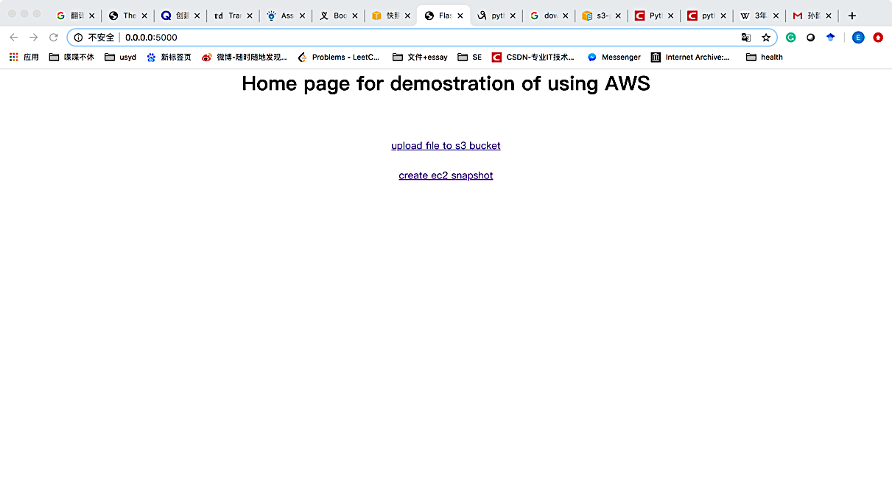

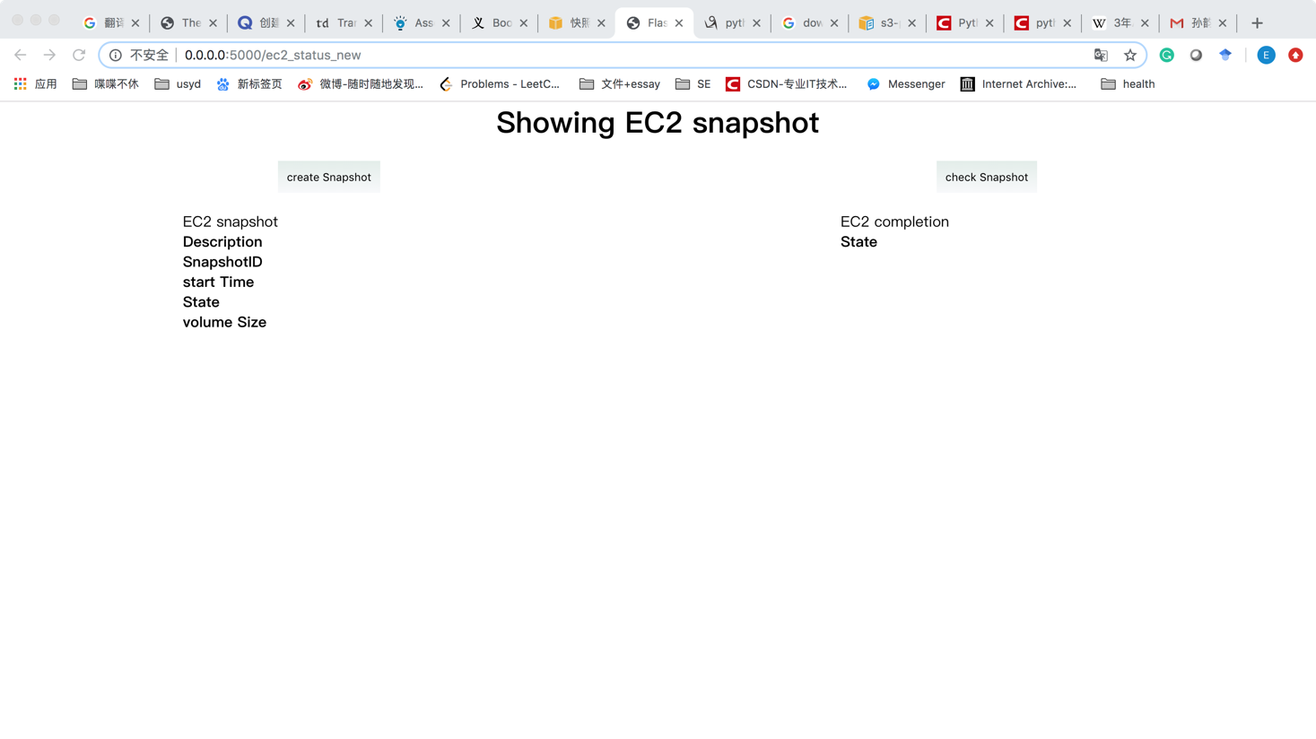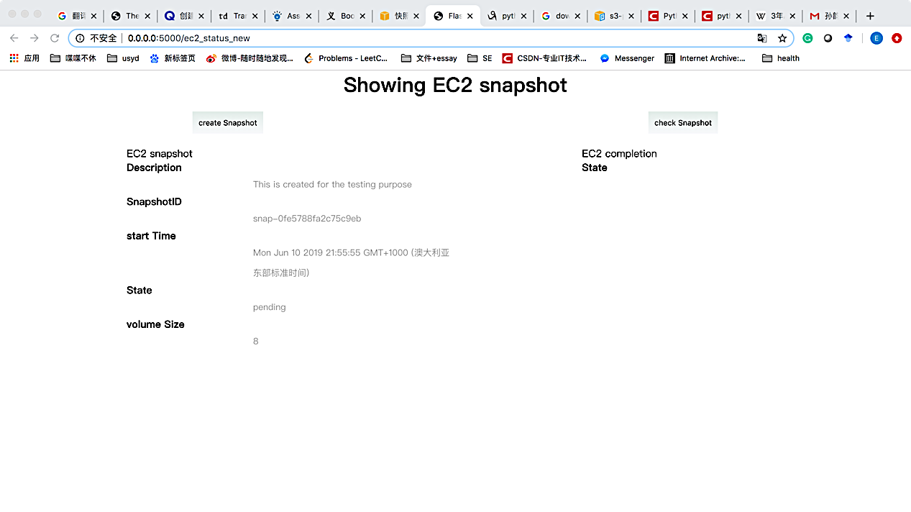

**Click here to create snapshot**

**Detail information of the snapshot will be shown**

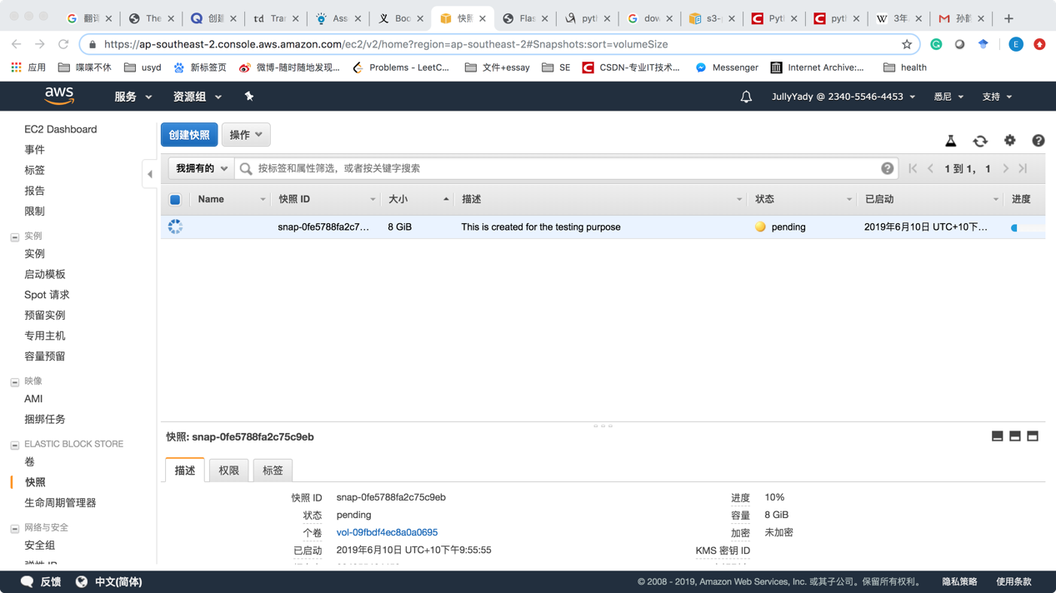

**The actual snapshot can be seen on the console**

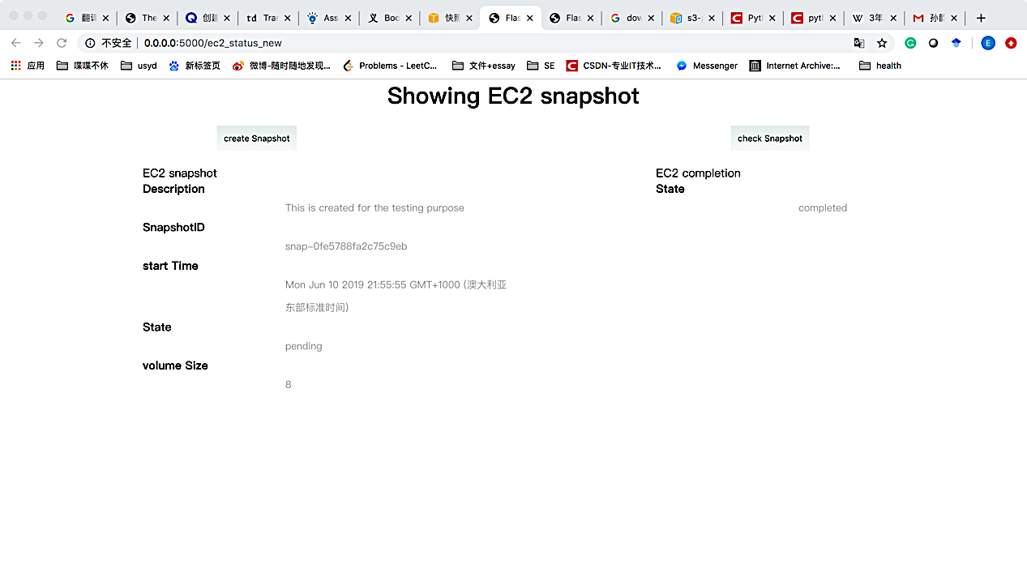

**The actual snapshot can be seen on the console**

# S3 bucket upload

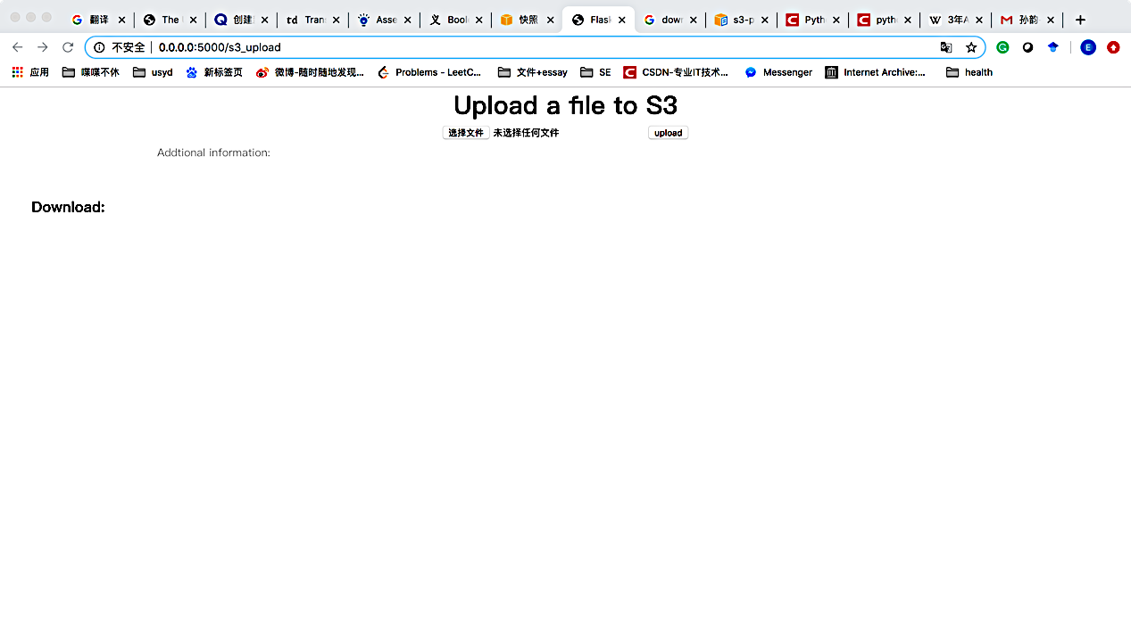

**Upload clicking here**

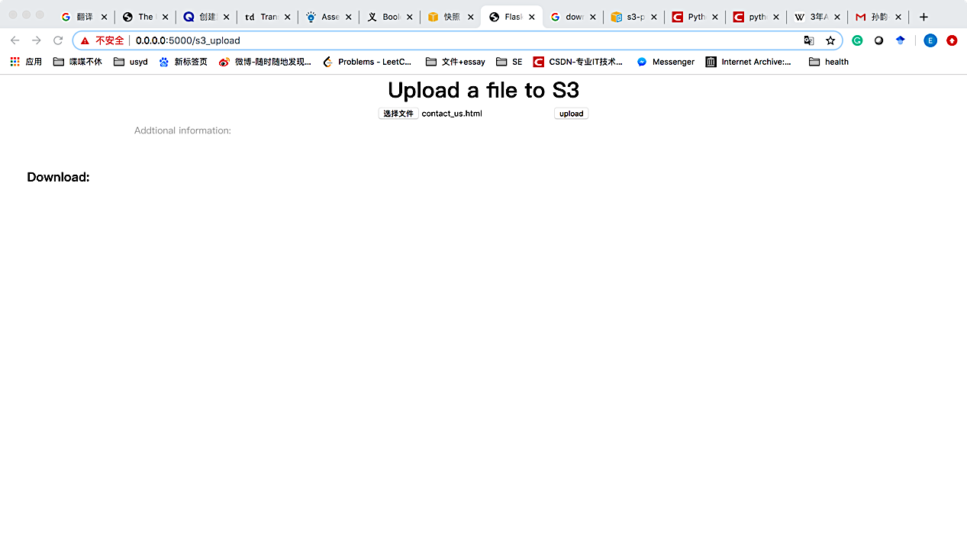

**Click upload to actually upload the file**

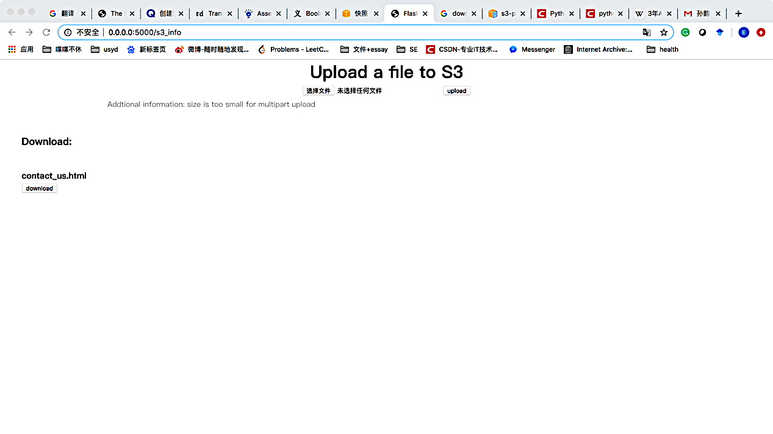

**Download the file from here.**

**File to small**

As the chosen file is smaller than 5M, it is not allowed to perform a multi-part upload, and the information will pop out.

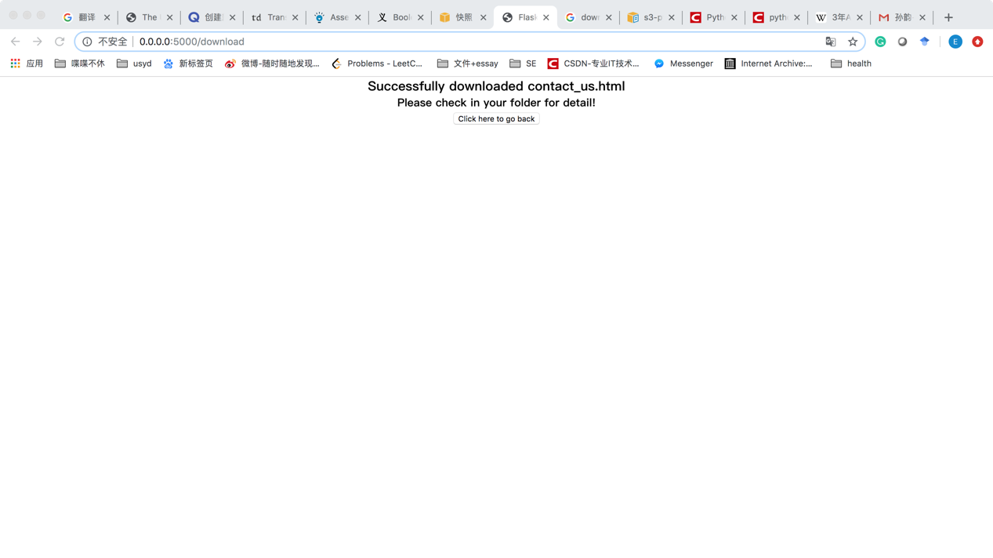

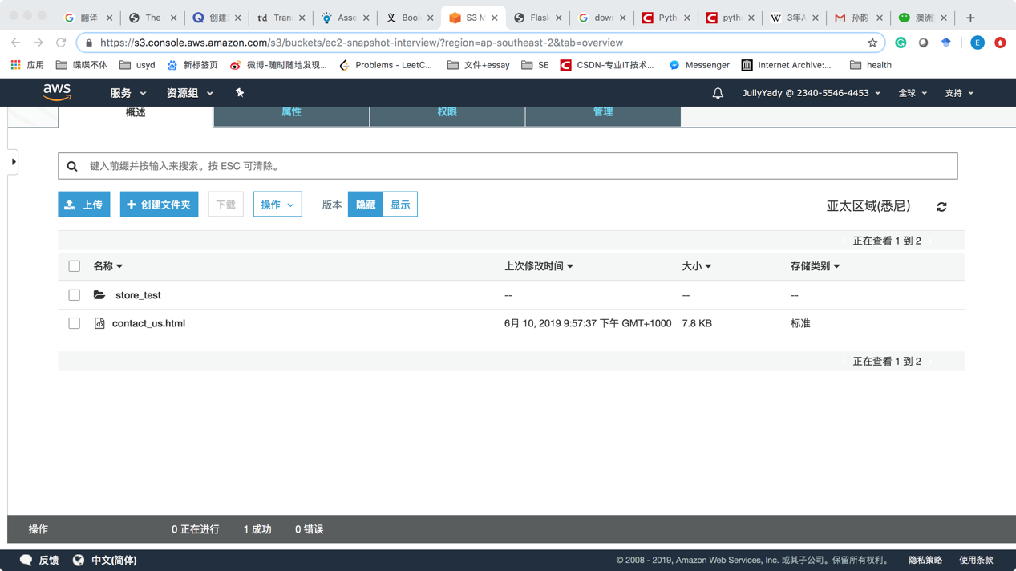

**Uploaded successfully!**